Project Report Format

1. INTRODUCTION
1.1 Project Overview
1.2 Purpose

2. IDEATION PHASE
2.1 Problem Statement
2.2 Empathy Map Canvas
2.3 Brainstorming

3. REQUIREMENT ANALYSIS
3.1 Customer Journey map
3.2 Solution Requirement
3.3 Data Flow Diagram
3.4 Technology Stack

4. PROJECT DESIGN
4.1 Problem Solution Fit
4.2 Proposed Solution
4.3 Solution Architecture

5. PROJECT PLANNING & SCHEDULING
5.1 Project Planning

6. FUNCTIONAL AND PERFORMANCE TESTING
6.1 Performance Testing

7. RESULTS
7.1 Output Screenshots

8. ADVANTAGES & DISADVANTAGES

9. CONCLUSION

10. FUTURE SCOPE

11. APPENDIX
Source Code(if any)
GitHub & Project Demo Link

1. Introduction
Employee management is one of the most important functions in every organization. Managing employee onboarding and offboarding manually often leads to delays, paperwork, communication gaps, and human errors. Organizations require an automated system that can efficiently manage employee records, approvals, notifications, and departmental tasks.
The Employee Management System is a ServiceNow-based application developed using App Engine Studio to automate employee lifecycle processes. The application provides a centralized platform for managing employee information, onboarding requests, offboarding requests, approval workflows, email notifications, and task assignments for HR, IT, and Security teams. By automating these processes, the system improves efficiency, reduces manual effort, and ensures a smooth employee experience.

2. Project Overview
The Employee Management System is a low-code application developed on the ServiceNow Platform using App Engine Studio and Flow Designer. The application manages the complete employee onboarding and offboarding process through automated workflows.
The system allows employees or HR administrators to create onboarding and offboarding requests. Once a request is submitted, it is automatically routed to the appropriate manager for approval. Based on the approval decision, the system performs predefined actions such as creating HR, IT, and Security tasks, sending email notifications, updating request status, and maintaining employee records.
The project also implements Access Control Lists (ACLs) to ensure that only authorized users can access and modify application data. The automation provided by the system minimizes manual work, improves process transparency, and enables better coordination between departments.

3. Purpose of the Project
The primary purpose of this project is to automate the employee onboarding and offboarding process using the ServiceNow platform. The project aims to eliminate manual processing, reduce administrative workload, and improve the efficiency of HR operations.
The objectives of the project include:
- Automate employee onboarding and offboarding workflows.
- Maintain centralized employee records.
- Implement manager approval workflows.
- Automatically generate HR, IT, and Security tasks.
- Send automated email notifications during each process.
- Improve process tracking and transparency.
- Secure application data using Role-Based Access Control (ACLs).
- Reduce manual errors and increase organizational productivity.
By implementing this solution, organizations can manage the employee lifecycle more efficiently while providing a faster, secure, and standardized process for all stakeholders.

2.IDEATION PHASE
2.2 Empathize & Discover

Date | 28 June 2026
Team ID | SWTID-2026-4885
Project Name | Automated Employee Onboarding & Off boarding System
Maximum Marks | 4 Marks

Empathy Map Canvas:
An empathy map is a simple, easy-to-digest visual that captures knowledge about a user’s behaviours and attitudes.

It is a useful tool to helps teams better understand their users.
Creating an effective solution requires understanding the true problem and the person who is experiencing it. The exercise of creating the map helps participants consider things from the user’s perspective along with his or her goals and challenges.
Example:
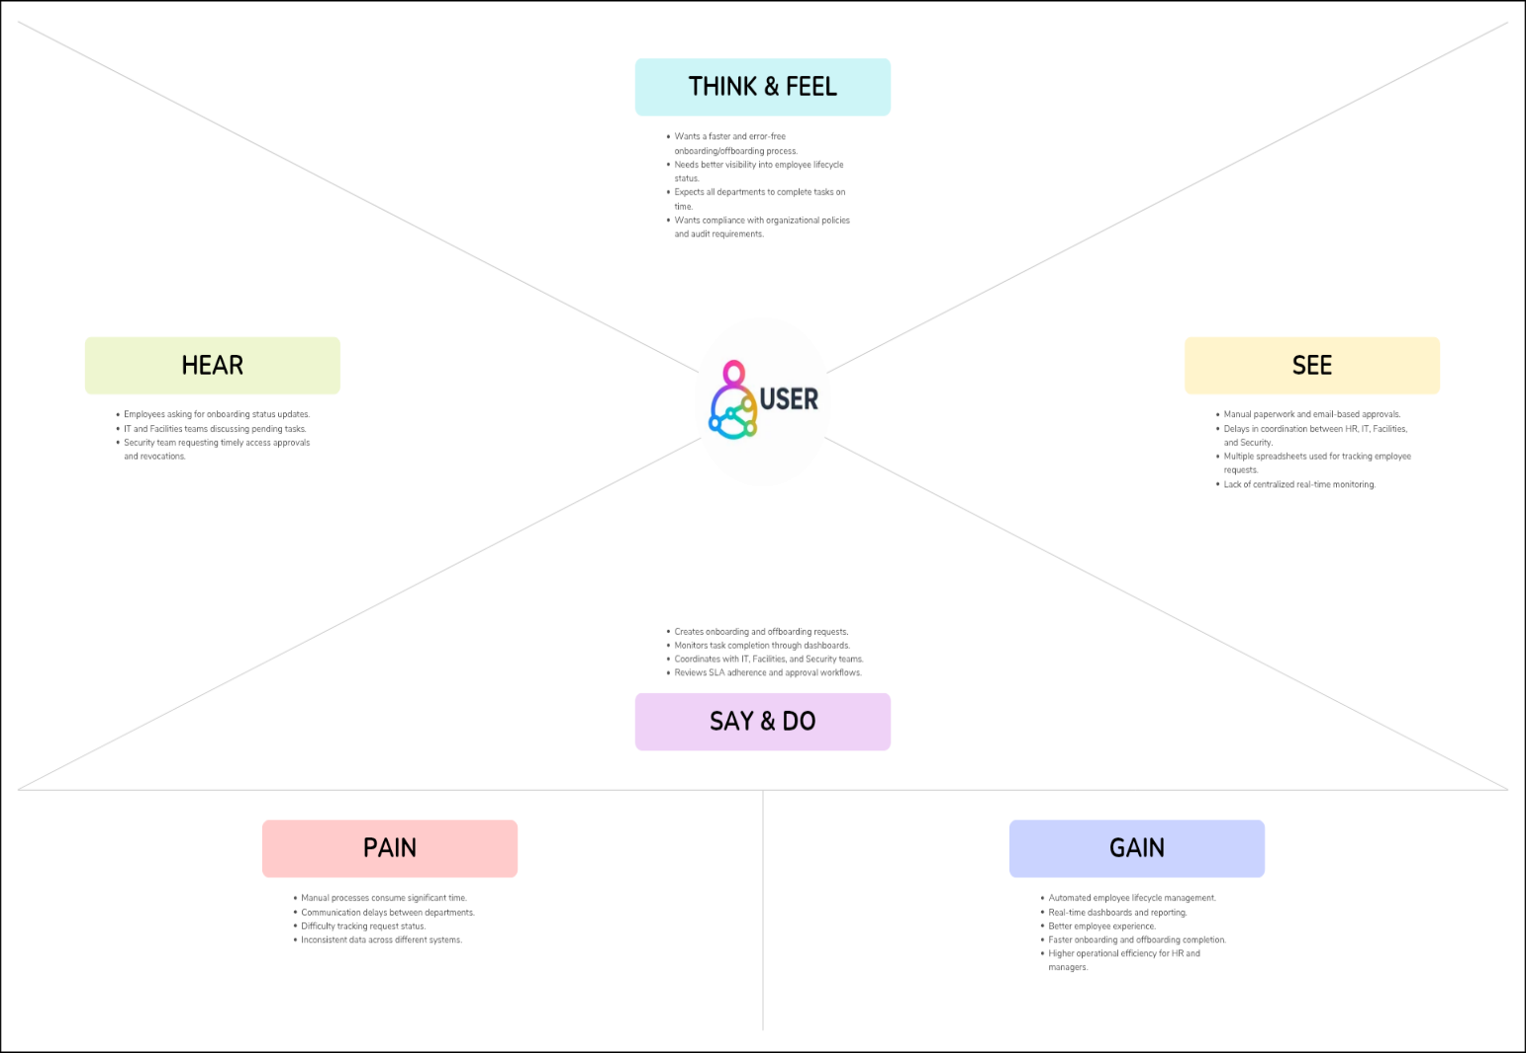

Ideation Phase
Define the Problem Statements

Date | 28 June 2026
Team ID | SWTID-2026-4885
Project Name | Automated Employee Onboarding & Off boarding System
Maximum Marks | 2 Marks

Customer Problem Statement Template:
Create a problem statement to understand your customer's point of view. The Customer Problem Statement template helps you focus on what matters to create experiences people will love.
A well-articulated customer problem statement allows you and your team to find the ideal solution for the challenges your customers face. Throughout the process, you’ll also be able to empathize with your customers, which helps you better understand how they perceive your product or service.
Example:
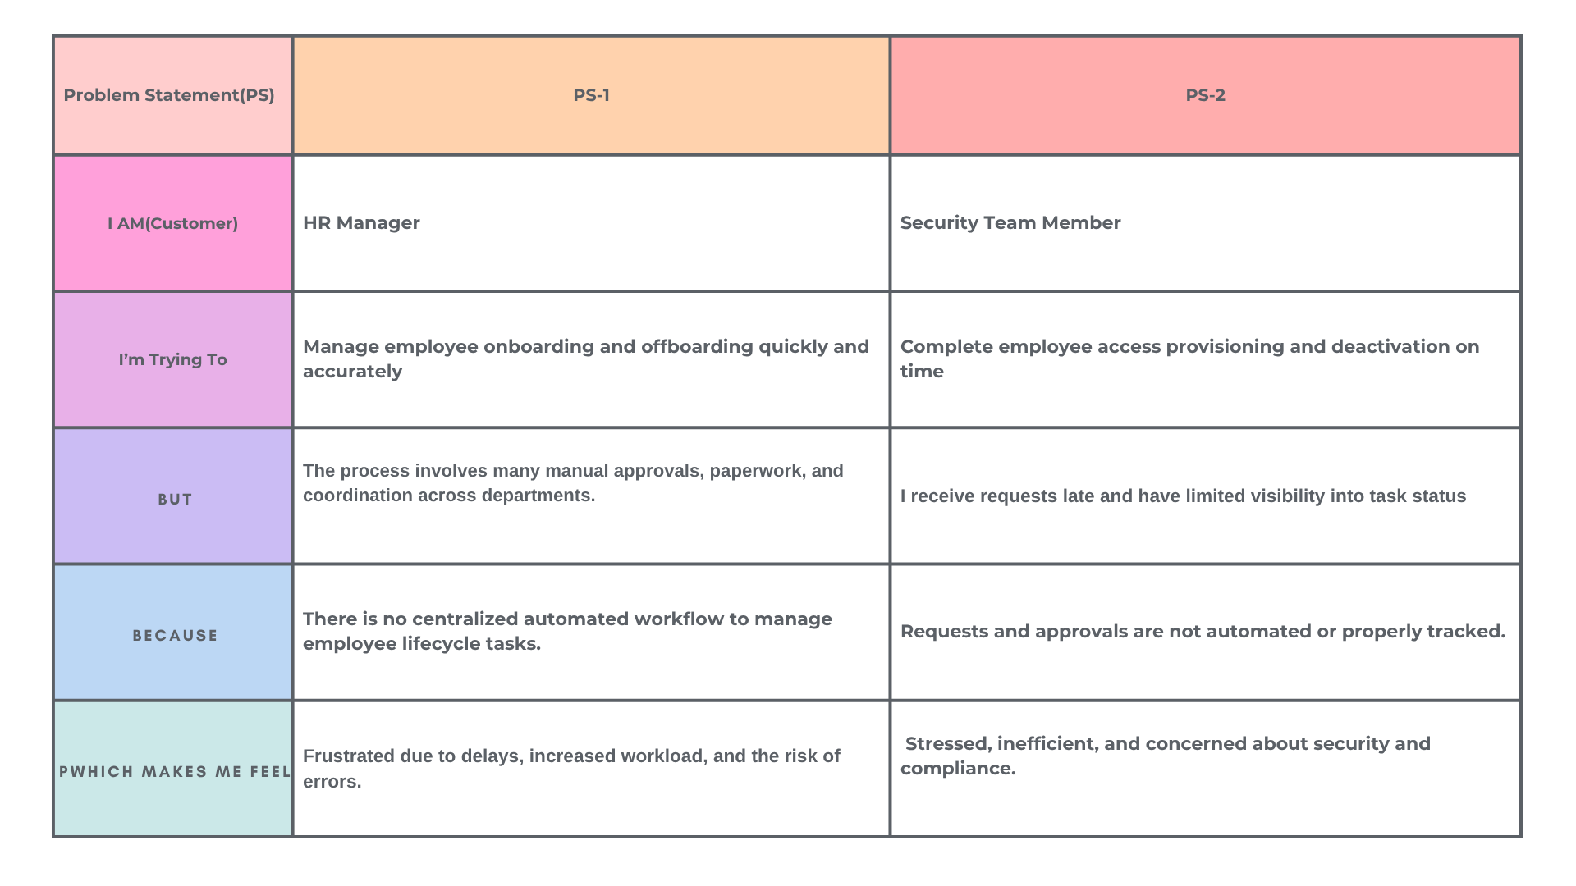

Ideation Phase
Brainstorm & Idea Prioritization Template

Date | 6 July 2026
Team ID | SWTID-2026-4885
Project Name | Automated Employee Onboarding & Off boarding System
Maximum Marks | 4 Marks

Brainstorm & Idea Prioritization Template:
Brainstorming provides a free and open environment that encourages everyone within a team to participate in the creative thinking process that leads to problem solving. Prioritizing volume over value, out-of-the-box ideas are welcome and built upon, and all participants are encouraged to collaborate, helping each other develop a rich amount of creative solutions.
Use this template in your own brainstorming sessions so your team can unleash their imagination and start shaping concepts even if you're not sitting in the same
Step-1:Team Gathering, Collaboration and Select the Problem Statement

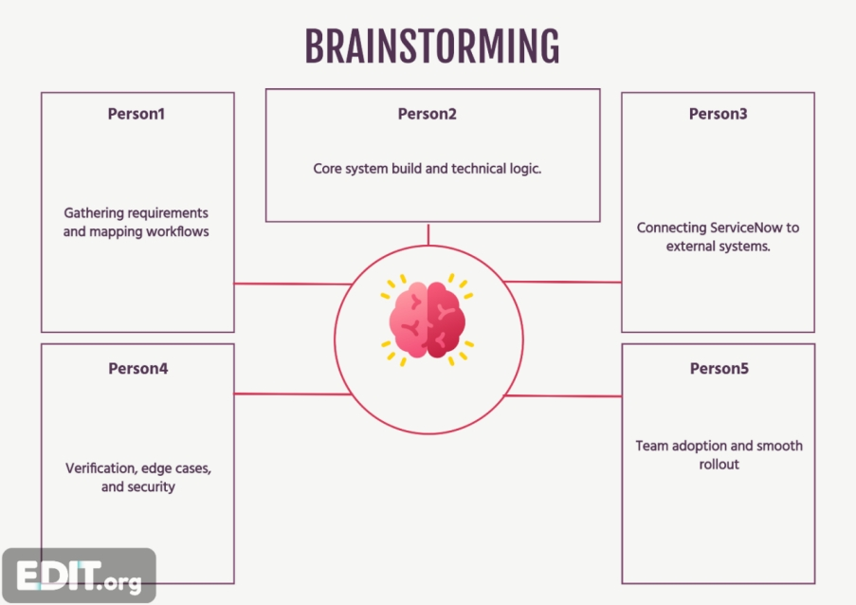

Step 2: Brainstorming, Idea Listing and Grouping
S.No | Idea Description | Category
1 | Automate employee onboarding request process | Workflow Automation
2 | Automate employee offboarding process | Workflow Automation
3 | Create Service Catalog items for onboarding and offboarding | Service Catalog
4 | Generate automatic tasks for HR, IT, Facilities and Security | Task Automation
5 | Configure approval workflows using Flow Designer | Approval Management
6 | Implement role-based ACLs for secure access | Security
7 | Configure SLA monitoring for task completion | SLA Management
8 | Send automatic email notifications | Notification System
9 | Design HR dashboards and reports | Dashboard & Reporting
10 | Track employee lifecycle status in real time | Employee Tracking
11 | Test complete onboarding/offboarding workflow | Testing
12 | Improve compliance using audit trails | Compliance

Project Design Phase-II
Solution Requirements (Functional & Non-functional)

Date | 06 July 2026
Team ID | SWTID-2026-4885
Project Name | Automated Employee Onboarding & Off boarding System
Maximum Marks | 4 Marks

Solution Requirements - Employee Management System
Functional Requirements
FR No | Functional Requirement | Description
FR-1 | Employee Management | Create and maintain employee records.
FR-2 | Onboarding Process | Submit onboarding request, manager approval, create HR/IT/Security tasks.
FR-3 | Offboarding Process | Submit offboarding request, manager approval, create exit tasks.
FR-4 | Workflow Automation | Automate approvals, email notifications and record updates using Flow Designer.
FR-5 | Access Control | Allow only authorized users to create, read and update records using ACLs.

Non-Functional Requirements
NFR No | Requirement | Description
NFR-1 | Usability | Simple and user-friendly forms in App Engine Studio.
NFR-2 | Security | Role-based Access Control (ACL) protects application data.
NFR-3 | Reliability | Flows execute consistently with approvals and notifications.
NFR-4 | Performance | Automation reduces manual effort and processing time.
NFR-5 | Availability | Application is available on the ServiceNow cloud platform.
NFR-6 | Scalability | Can be extended with additional HR processes and modules.

Project Design Phase-II
Data Flow Diagram & User Stories

Date | 06 July 2026
Team ID | SWTID-2026-4885
Project Name | Automated Employee Onboarding & Off boarding System
Maximum Marks | 4 Marks

Data Flow Diagrams:
A Data Flow Diagram (DFD) is a traditional visual representation of the information flows within a system. A neat and clear DFD can depict the right amount of the system requirement graphically. It shows how data enters and leaves the system, what changes the information, and where data is stored.

User Stories
Use the below template to list all the user stories for the product.
User Type | Functional Requirement (Epic) | User Story Number | User Story / Task | Acceptance Criteria | Priority | Release
Employee | Employee Registration | USN-1 | As an employee, I can create a new employee record with personal and job details. | Employee record is successfully created. | High | Sprint-1
Employee | Onboarding Request | USN-2 | As an employee, I can submit an onboarding request. | Onboarding request is submitted successfully. | High | Sprint-1
Manager | Approval | USN-3 | As a manager, I can approve or reject onboarding requests. | Manager can approve/reject and status updates correctly. | High | Sprint-1
HR | Employee Onboarding | USN-4 | As an HR user, I can receive and complete onboarding tasks. | HR task is automatically created after approval. | High | Sprint-1
IT | IT Provisioning | USN-5 | As an IT user, I can receive tasks to create user accounts and assign assets. | IT task is created automatically. | Medium | Sprint-1
Employee | Offboarding Request | USN-6 | As an employee, I can submit an offboarding request. | Offboarding request is submitted successfully. | High | Sprint-2
Manager | Offboarding Approval | USN-7 | As a manager, I can approve or reject offboarding requests. | Status updates based on manager decision. | High | Sprint-2
HR | Exit Process | USN-8 | As an HR user, I can process employee exit formalities. | HR offboarding task is created automatically. | Medium | Sprint-2
IT | Access Revocation | USN-9 | As an IT user, I can disable employee accounts and collect assets. | IT offboarding task is completed successfully. | Medium | Sprint-2
Security | Building Access | USN-10 | As a security user, I can deactivate employee building access. | Security task is created and completed successfully. | Medium | Sprint-2
Administrator | Access Control | USN-11 | As an administrator, I can manage roles and access permissions for users. | Authorized users can access only permitted records. | High | Sprint-2
Administrator | Notifications | USN-12 | As an administrator, I can configure email notifications for approvals and requests. | Email notifications are sent successfully. | Medium | Sprint-2

Project Design Phase-II
Technology Stack (Architecture & Stack)

Date | 06 July 2026
Team ID | SWTID-2026-4885
Project Name | Automated Employee Onboarding & Off boarding System
Maximum Marks | 4 Marks

Technical Architecture:
The Deliverable shall include the architectural diagram as below and the information as per the table1 & table 2
Technology Stack - Employee Management System
Component | Description | Technology
User Interface | Application forms and lists | ServiceNow App Engine Studio
Application Logic | Workflow automation | Flow Designer
Approval Engine | Manager approvals | Ask for Approval Action
Database | Employee, Onboarding, Offboarding tables | ServiceNow Custom Tables
Notifications | Email alerts | ServiceNow Notification/Send Email
Security | Access Control | Roles and ACLs
Platform | Deployment | ServiceNow Personal Developer Instance (Cloud)

Project Design Phase
Problem – Solution Fit Template

Date | 06 July 2026
Team ID | SWTID-2026-4885
Project Name | Automated Employee Onboarding & Off boarding System
Maximum Marks | 2 Marks

Problem – Solution Fit Template:

The Problem-Solution Fit simply means that you have found a problem with your customer and that the solution you have realized for it actually solves the customer’s problem. It helps entrepreneurs, marketers and corporate innovators identify behavioral patterns and recognize what would work and why
Purpose:

- Solve complex problems in a way that fits the state of your customers.

- Succeed faster and increase your solution adoption by tapping into existing mediums and channels of behavior.

- Sharpen your communication and marketing strategy with the right triggers and messaging.

- Increase touch-points with your company by finding the right problem-behavior fit and building trust by solving frequent annoyances, or urgent or costly problems.

- Understand the existing situation in order to improve it for your target group.

Section | Description
- Customer Segment(s) | Employees, HR Team, Managers
- Jobs-to-be-done | Employee Onboarding, Employee Offboarding, Approval Process
- Triggers | New Employee Joining, Employee Resignation
- Emotions (Before / After) | Before: Manual Process, Delays. After: Fast, Automated and Transparent Process
- Available Solutions | Manual Forms, Email Process, ServiceNow Automation
- Customer Constraints | Manual Work, Delayed Approvals, Tracking Issues
- Behaviour | HR verifies requests, Manager approves/rejects requests, IT completes assigned tasks
- Channels | Online: ServiceNow Platform, Email Notifications. Offline: HR Team Communication
- Problem Root Cause | Manual Process, No Centralized Tracking, Human Errors
- Your Solution | Developed an Employee Management System using ServiceNow App Engine Studio. Automated employee onboarding and offboarding with Flow Designer, Manager Approval, Email Notifications, HR/IT/Security Tasks, and Access Control (ACLs).

Project Design Phase
Proposed Solution Template
Date | 06 July 2026
Team ID | SWTID-2026-4885
Project Name | Automated Employee Onboarding & Off boarding System
Maximum Marks | 2 Marks

Proposed Solution Template
Project team shall fill the following information in the proposed solution template.
S.No. | Parameter | Description
 | Problem Statement (Problem to be solved) | Organizations face delays and manual effort in employee onboarding and offboarding. Employee records, approvals, task assignments, and notifications are handled manually, leading to errors, lack of transparency, and inefficient tracking.
 | Idea / Solution description | Develop an Employee Management System using ServiceNow App Engine Studio. The application automates employee onboarding and offboarding through custom tables, Flow Designer workflows, manager approvals, email notifications, HR/IT/Security task creation, and Access Control Lists (ACLs).
 | Novelty / Uniqueness | Provides a centralized platform that integrates employee management, workflow automation, approvals, notifications, and security within a single ServiceNow application, reducing manual intervention.
 | Social Impact / Customer Satisfaction | Improves employee experience with faster onboarding and offboarding, reduces HR workload, increases transparency, and ensures timely completion of organizational processes.
 | Business Model (Revenue Model) | Can be deployed as an enterprise HR workflow solution for organizations using ServiceNow. Revenue can be generated through software licensing, implementation services, customization, and annual maintenance.
 | Scalability of the Solution | The solution can be extended to include leave management, attendance, payroll integration, asset management, employee self-service, and additional HR workflows wit

Project Design Phase
Solution Architecture

Date | 06 July 2026
Team ID | SWTID-2026-4885
Project Name | Automated Employee Onboarding & Off boarding System
Maximum Marks | 4 Marks

Solution Architecture:

Solution architecture is a complex process – with many sub-processes – that bridges the gap between business problems and technology solutions. Its goals are to:
- Find the best tech solution to solve existing business problems.
- Describe the structure, characteristics, behavior, and other aspects of the software to project stakeholders.
- Define features, development phases, and solution requirements.
- Provide specifications according to which the solution is defined, managed, and delivered.

Example - Solution Architecture Diagram:

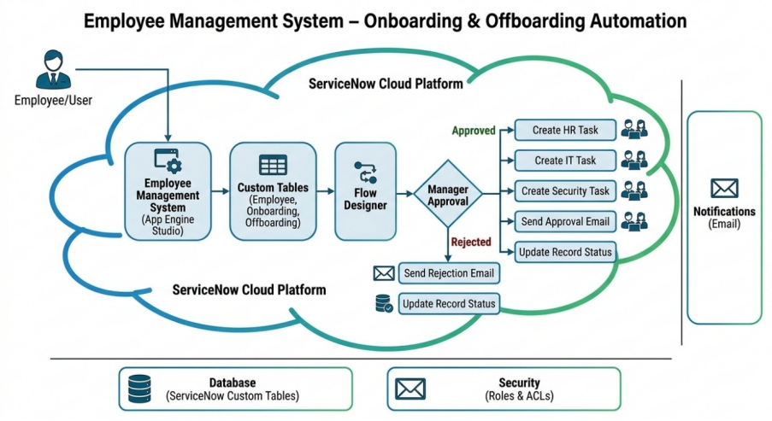

Sprint 1
Employee Management (Epic 1)
User Story | Story Points
Create Employee Table (USN-1) | 2
Create Employee Form (USN-2) | 2
Create Onboarding Table (USN-3) | 3
Onboarding Process (Epic 2)
User Story | Story Points
Build Onboarding Flow (USN-4) | 5
Configure Approval Process (USN-5) | 3
Configure Email Notification (USN-6) | 2
Total Story Points Sprint-1
2 + 2 + 3 + 5 + 3 + 2 = 17

Sprint 2
Offboarding Process (Epic 3)
User Story | Story Points
Create Offboarding Table (USN-7) | 3
Build Offboarding Flow (USN-8) | 5
Create HR/IT/Security Tasks (USN-9) | 5
Security (Epic 4)
User Story | Story Points
Configure Access Control (USN-10) | 3
Testing & Validation (USN-11) | 2
Total Story Points Sprint-2
3 + 5 + 5 + 3 + 2 = 18

Total Story Points
Sprint-1 = 17
Sprint-2 = 18
Total Story Points = 35
Number of Sprints = 2
Velocity = 35 / 2 = 17.5 ≈ 18 Story Points per Sprint

Project Planning Phase
Project Planning Template (Product Backlog, Sprint Planning, Stories, Story points)

Date | 06 July 2026
Team ID | SWTID-2026-4885
Project Name | Automated Employee Onboarding & Off boarding System
Maximum Marks | 5 Marks

Product Backlog, Sprint Schedule, and Estimation (4 Marks)
Sprint | Functional Requirement (Epic) | User Story Number | User Story / Task | Story Points | Priority | Team Members
Sprint-1 | Employee Management | USN-1 | Create Employee Table | 2 | High | Team
Sprint-1 | Employee Management | USN-2 | Create Employee Form | 2 | High | Team
Sprint-1 | Employee Management | USN-3 | Create Onboarding Table | 3 | High | Team
Sprint-1 | Workflow Automation | USN-4 | Develop Onboarding Flow | 5 | High | Team
Sprint-1 | Workflow Automation | USN-5 | Configure Manager Approval | 3 | High | Team
Sprint-1 | Notification | USN-6 | Configure Email Notification | 2 | Medium | Team
Sprint-2 | Employee Offboarding | USN-7 | Create Offboarding Table | 3 | High | Team
Sprint-2 | Employee Offboarding | USN-8 | Develop Offboarding Flow | 5 | High | Team
Sprint-2 | Task Automation | USN-9 | Create HR, IT & Security Tasks | 5 | High | Team
Sprint-2 | Security | USN-10 | Configure Access Control (ACL) | 3 | Medium | Team
Sprint-2 | Testing | USN-11 | Test and Validate Complete Application | 2 | High | Team

Sprint | Total Story Points | Duration | Sprint Start Date | Sprint End Date (Planned) | Story Points Completed | Sprint Release Date
Sprint-1 | 17 | 6 Days | 01 Feb 2025 | 06 Feb 2025 | 17 | 06 Feb 2025
Sprint-2 | 18 | 6 Days | 08 Feb 2025 | 13 Feb 2025 | 18 | 13 Feb 2025

Acceptance Testing
UAT Execution & Report Submission
Date | 06 July 2026
Team ID | SWTID-2026-4885
Project Name | Automated Employee Onboarding & Off boarding System
Maximum Marks | 4 Marks

1. Purpose of Document
The purpose of this document is to briefly explain the test coverage and open issues of the [ProductName] project at the time of the release to User Acceptance Testing (UAT).
2. Defect Analysis
This report shows the number of resolved or closed bugs at each severity level, and how they were resolved
Resolution | Severity 1 | Severity 2 | Severity 3 | Severity 4 | Subtotal
By Design | 10 | 4 | 2 | 3 | 20
Duplicate | 1 | 0 | 3 | 0 | 4
External | 2 | 3 | 0 | 1 | 6
Fixed | 11 | 2 | 4 | 20 | 37
Not Reproduced | 0 | 0 | 1 | 0 | 1
Skipped | 0 | 0 | 1 | 1 | 2
Won't Fix | 0 | 5 | 2 | 1 | 8

Totals 24 14 13 26 77
3. Test Case Analysis
This report shows the number of test cases that have passed, failed, and untested
Section | Total Cases | Not Tested | Fail | Pass
Print Engine | 7 | 0 | 0 | 7
Client Application | 51 | 0 | 0 | 51
Security | 2 | 0 | 0 | 2
Outsource Shipping | 3 | 0 | 0 | 3

Exception Reporting | 9 | 0 | 0 | 9
Final Report Output | 4 | 0 | 0 | 4

7. RESULTS

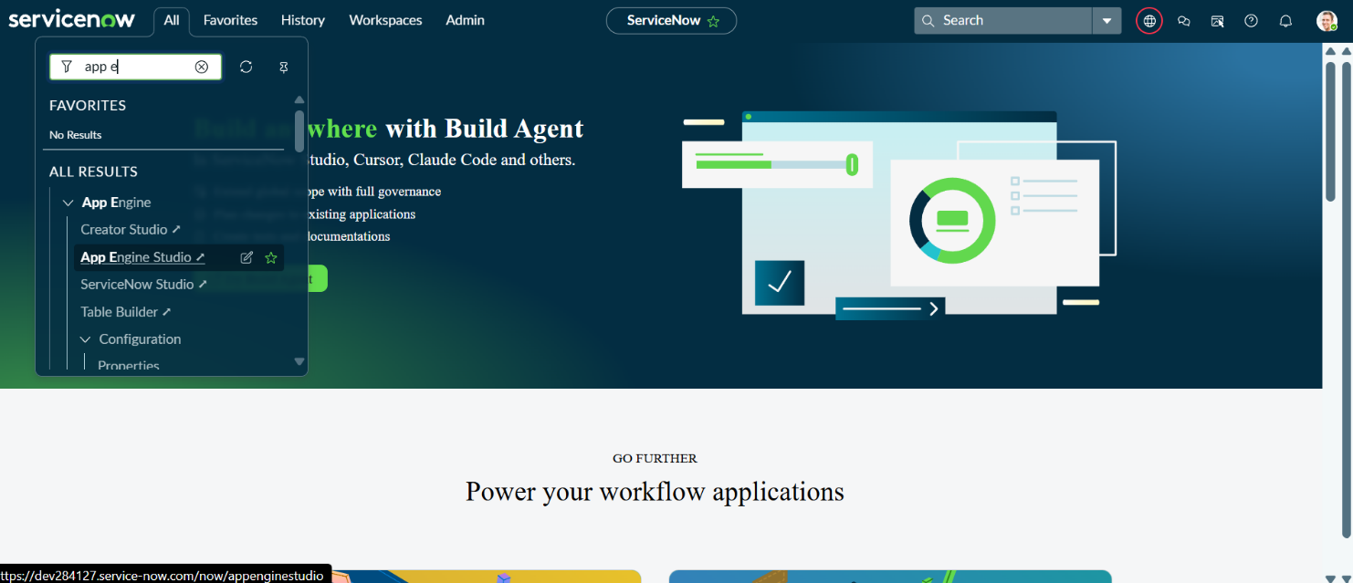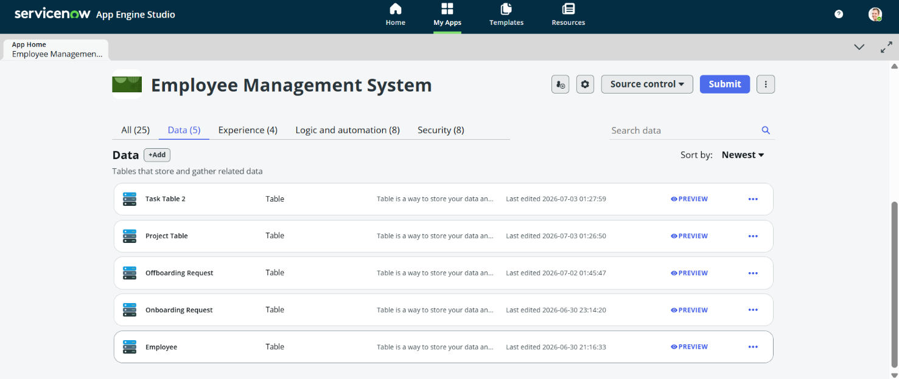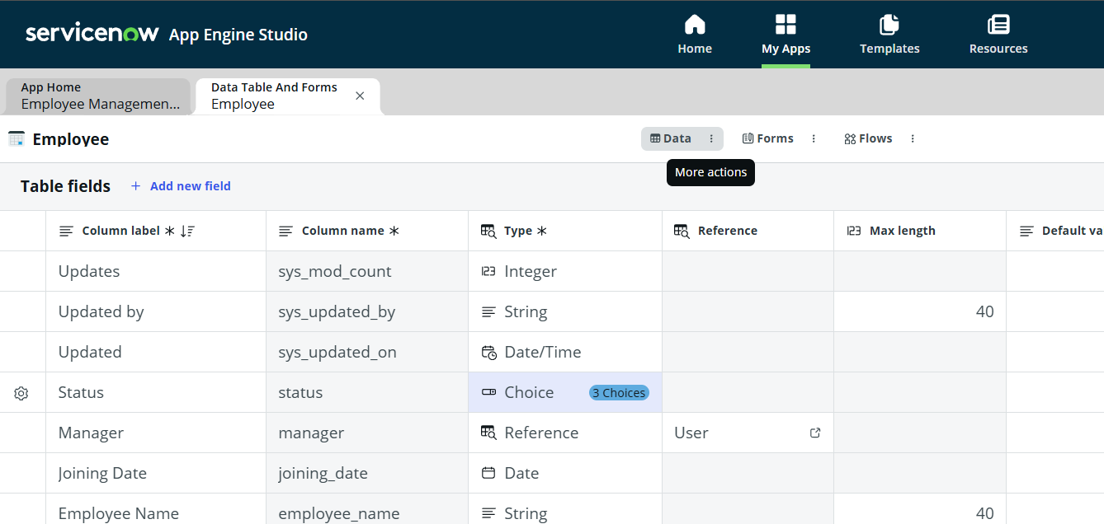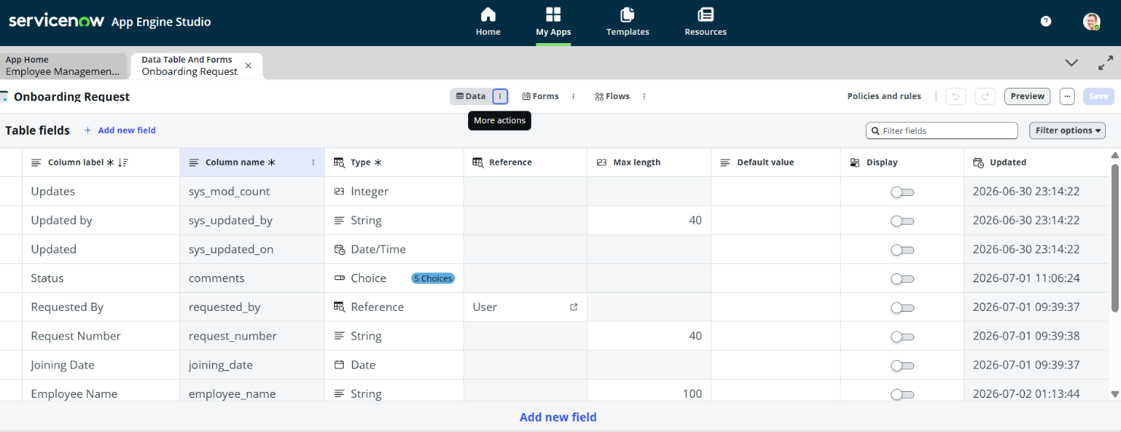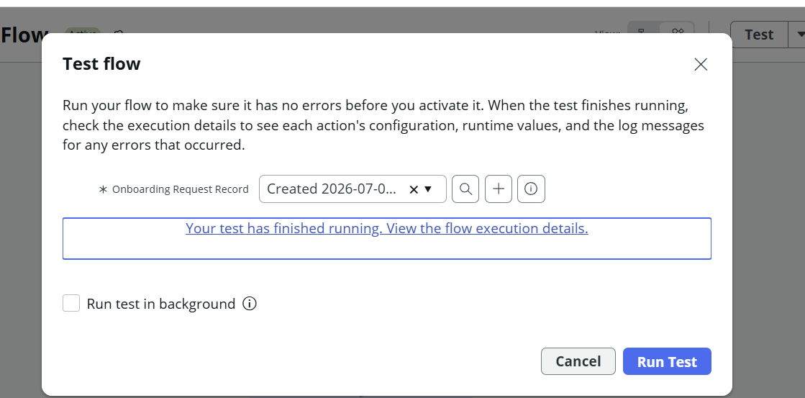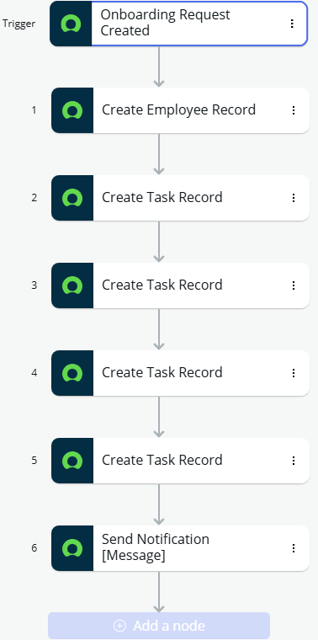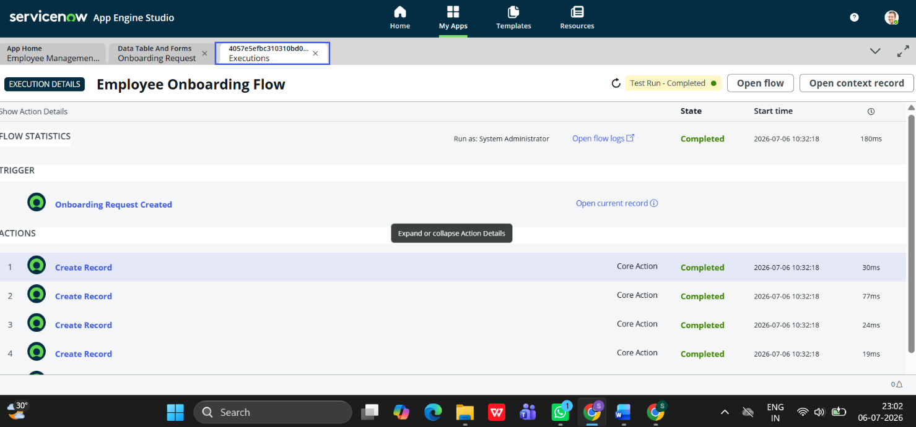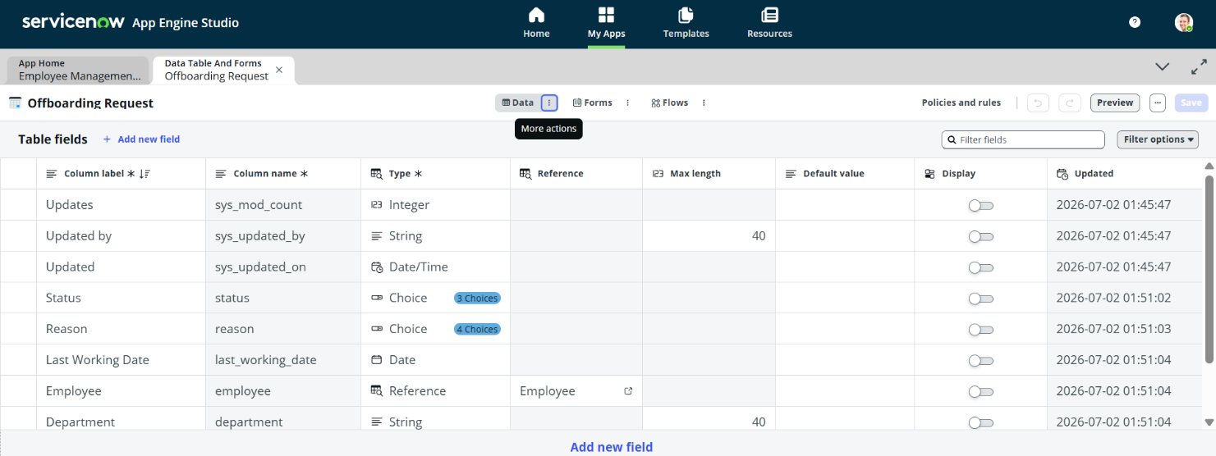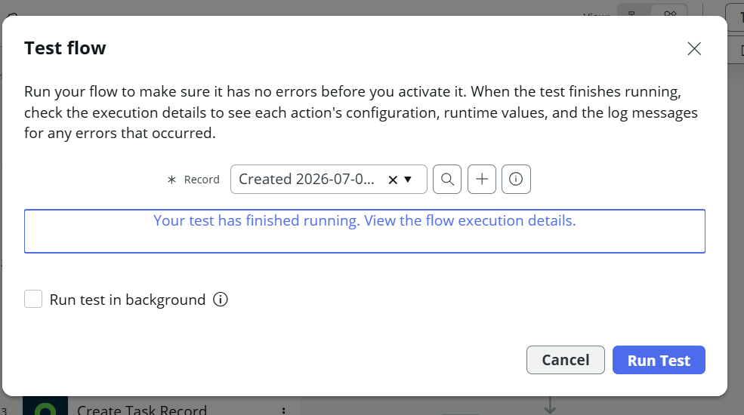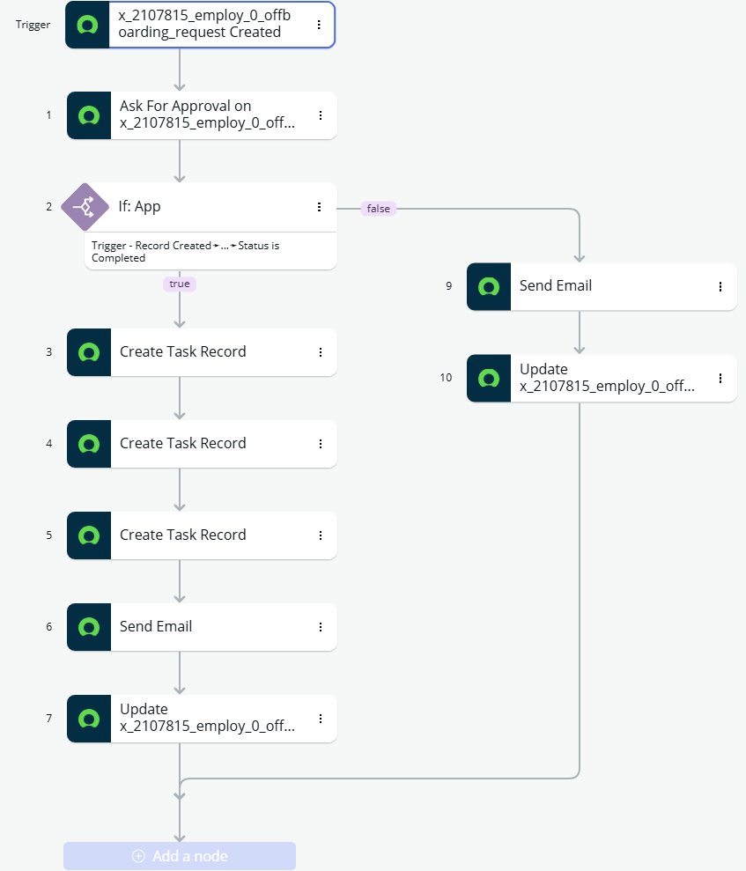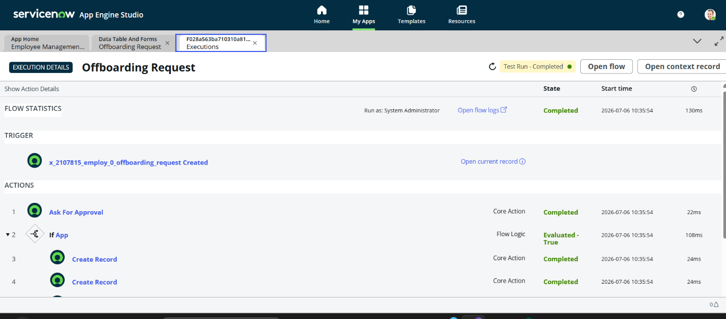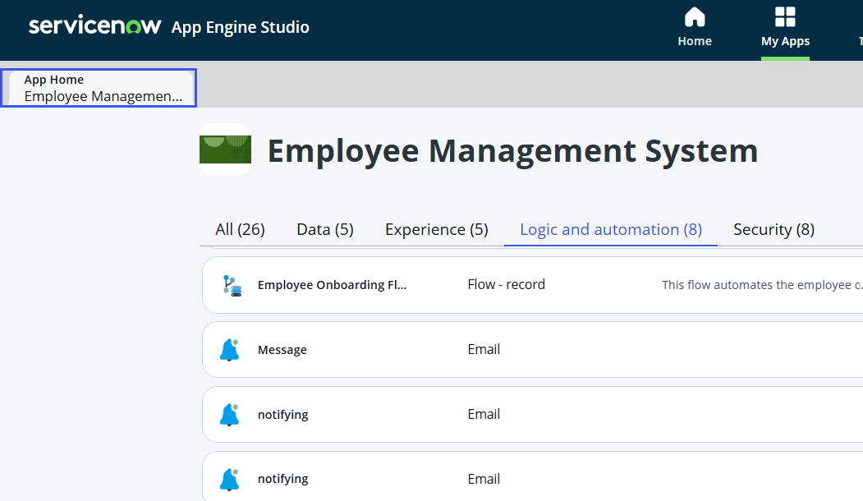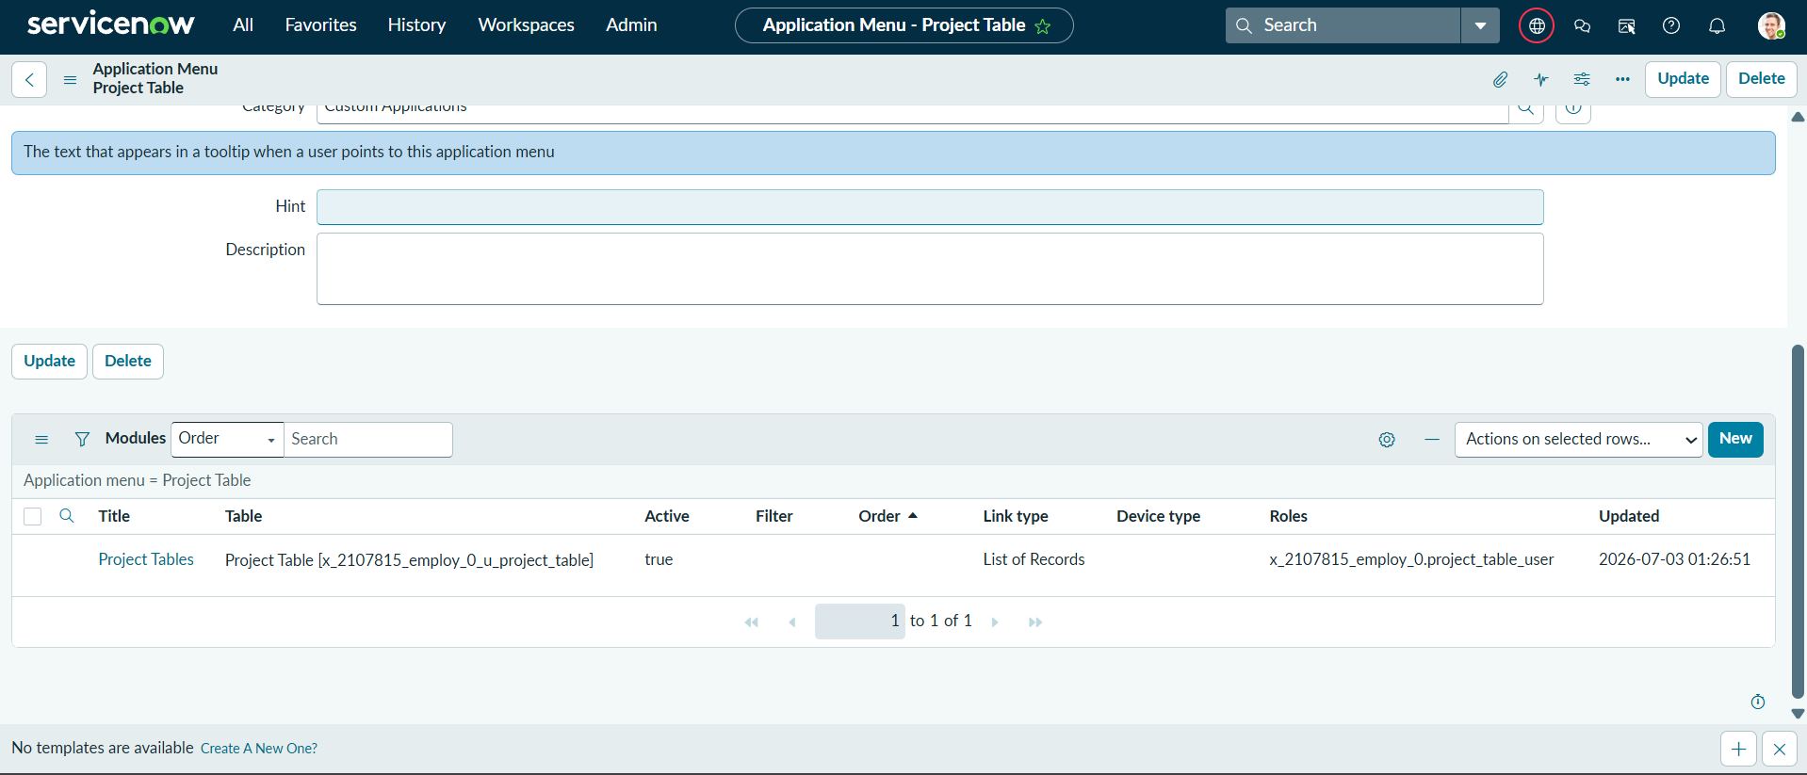

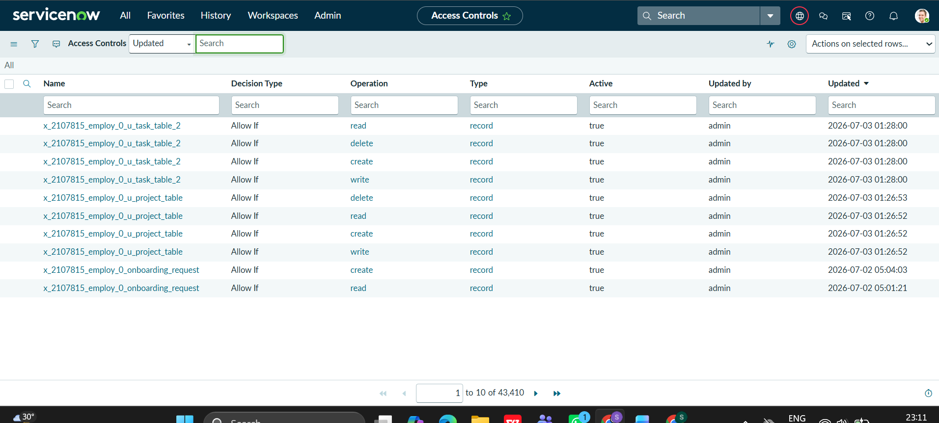

8. ADVANTAGES & DISADVANTAGES
Advantages of the Employee Management System
- Automates Employee Lifecycle
  - Automates onboarding and offboarding processes, reducing manual work and paperwork.
- Centralized Employee Data
  - Stores employee, onboarding, and offboarding information in a centralized ServiceNow application for easy management.
- Workflow Automation
  - Uses Flow Designer to automate approvals, task creation, email notifications, and status updates.
- Faster Approval Process
  - Manager approvals are processed electronically, reducing delays and improving efficiency.
- Automatic Task Creation
  - HR, IT, and Security tasks are automatically generated after approval, ensuring that all departments complete their responsibilities on time.
- Improved Communication
  - Email notifications keep employees and stakeholders informed about request status and approvals.
- Enhanced Security
  - Access Control Lists (ACLs) ensure that only authorized users can access or modify application data.
- Reduced Human Errors
  - Automation minimizes data entry mistakes and improves process accuracy.
- Easy Tracking
  - Employees and administrators can monitor the status of onboarding and offboarding requests throughout the process.
- Scalable Solution
  - The application can be extended with additional HR modules such as leave management, payroll integration, attendance tracking, and asset management.

Disadvantages of the Employee Management System
- ServiceNow Dependency
  - The application depends entirely on the ServiceNow platform and cannot function independently.
- Initial Configuration Time
  - Setting up tables, workflows, approvals, notifications, and security requires initial development effort.
- Training Requirement
  - HR staff and end users may require training to use the application effectively.
- Customization Complexity
  - Adding advanced features or integrating with external systems may require additional ServiceNow development skills.
- Internet Requirement
  - As a cloud-based application, a stable internet connection is required to access the system.
- Maintenance Required
  - The application requires periodic updates, workflow maintenance, and security reviews to ensure smooth operation.
- Role Management
  - Incorrect ACL or role configuration can prevent users from accessing required information or performing authorized actions.
- Limited Offline Access
  - The application cannot be used without access to the ServiceNow instance.

- FUTURE SCOPE

The Employee Management System – Onboarding & Offboarding Automation developed on the ServiceNow platform has significant future enhancement opportunities. The current system automates employee onboarding, offboarding, approvals, notifications, and task management. In the future, the project can be expanded into a complete HR management solution with advanced features.

Future Enhancements
- Leave Management Integration
  - Add employee leave request and approval workflows.
  - Track leave balances and attendance records.
- Payroll Integration
  - Integrate the system with payroll applications.
  - Automatically update employee status changes for salary processing.
- Asset Management
  - Track laptops, ID cards, software licenses, and other assets assigned to employees.
  - Automate asset allocation during onboarding and asset return during offboarding.
- Employee Self-Service Portal
  - Allow employees to submit requests, check status, update profiles, and view notifications through a self-service portal.
- Advanced Reporting and Dashboards
  - Create real-time dashboards for HR managers.
  - Generate reports for onboarding trends, offboarding statistics, approval times, and departmental performance.
- AI-Based Automation
  - Use ServiceNow AI capabilities to predict delays, recommend actions, and automate repetitive HR tasks.
- Integration with External Systems
  - Connect with Active Directory, email systems, payroll software, and third-party HR applications.
- Mobile Application Support
  - Provide mobile access for managers and employees to approve requests and track activities from anywhere.
- Document Management
  - Store employee documents such as offer letters, ID proofs, and exit documents securely within the system.
- Multi-Department Workflow Expansion
  - Extend the solution to Finance, Administration, Facilities, and other departments for organization-wide process automation.

Conclusion
The future scope of this project is to transform the current onboarding and offboarding automation system into a comprehensive enterprise-level Human Resource Management solution. By integrating additional HR modules, analytics, AI capabilities, mobile access, and external systems, the application can provide a highly scalable, secure, and intelligent employee lifecycle management platform for organizations of any size.

GITHUB LINK:
https://github.com/236K1A0526

